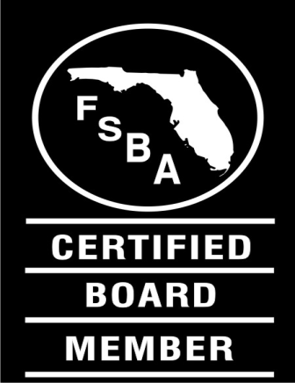
Florida School Boards Association
2017 SCHOOL
FINANCE FORUM

February 8, 2017

TENTATIVE AGENDA – check back often for updates (1/12/17)
7:30 a.m. Check-In / Breakfast Buffet

8:00 a.m. Welcome, Introductions, and Startups

The Florida Education Finance Program (FEFP)
· Overview of School Finance
· Full-Time Equivalent (FTE) Weights

· Enrollment Projections
· Base Student Allocation (BSA)
· District Cost Differentials (DCD)

12:00 noon WORKING LUNCH

12:45 p.m. The Florida Education Finance Program (FEFP)
· Additional Elements of the FEFP Formula
· Required Local Effort (RLE)
· Categorical Program and Lottery Funding

· Scholarships, Vouchers, and Corporate Tax Credits
· Capital Outlay
· Internal Accounts

The Budgetary Process

Truth in Millage (TRIM)

5:00 p.m. Dinner on Your Own

