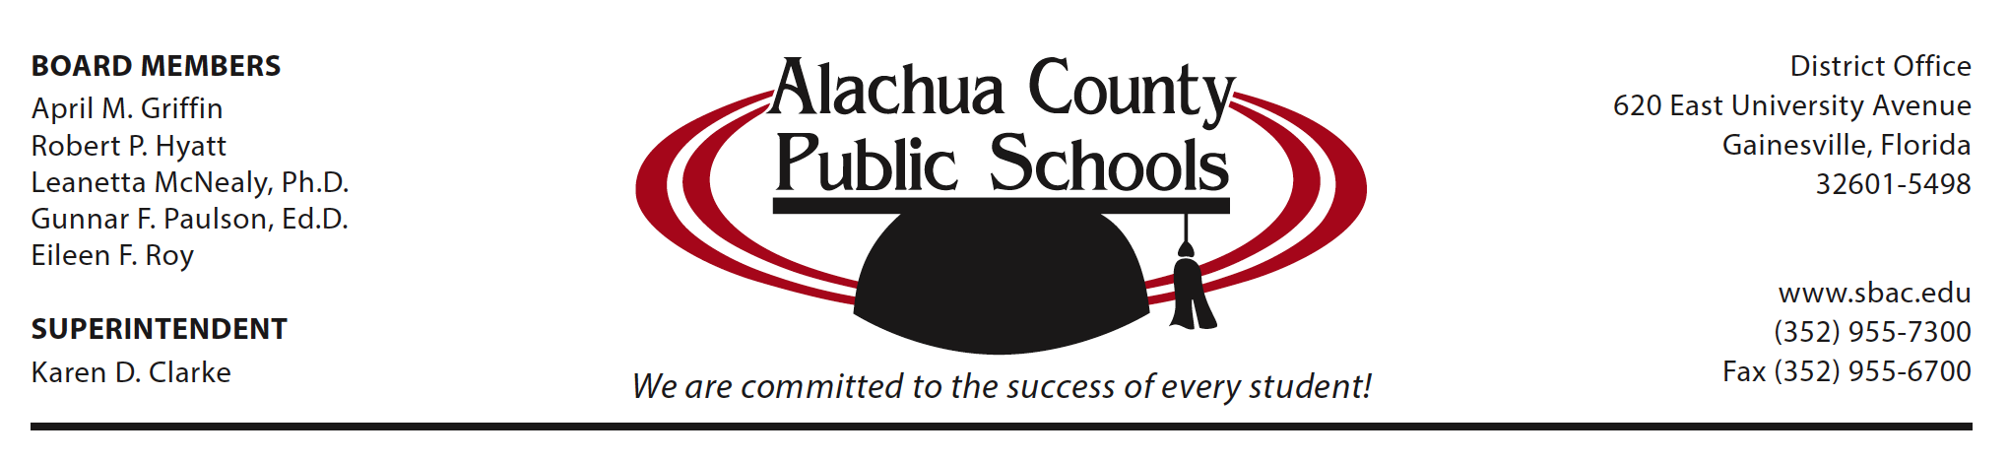
NEWS RELEASE

For more information, contact: For Immediate Release
Jackie Johnson/(352) 955-7545

Student wins national prize for mapping impact of hurricane

Among the many experts from a variety of scientific fields studying the aftermath of Hurricane Irma is a local middle school student whose work has won her national recognition.

Lincoln Middle School 8th grader Navya Tripathi, who also attends some classes at Buchholz High School, recently took first place in the first-ever ‘High School Geospatial Poster Competition’ sponsored by URISA, a professional organization for experts in the field of GIS (Geographic Information System).

According to the website GISGeography.com, GIS is a ‘computer-based tool that analyzes, stores, manipulates and visualizes geographic information, usually in a map.’ It has a huge variety of practical applications—mapping epidemics, for example, or city planning.

URISA has sponsored college-level competitions for several years, but this was the first time they invited younger students to submit their work. Besides conducting research and organizing it into a visual display, the competitors also had to share their work with a panel of expert judges.

Tripathi’s project, ‘Story Map of Hurricane Irma—An Account of Its Path, Damage and Response,’ is actually a collage of several maps through which she tracked a variety of data, everything from the storm surge and flooding that accompanied the hurricane to the response to evacuation orders and the use of shelters.

“This was the first hurricane I had ever experienced, and we were still in the hurricane season when the competition took place, so I found it very interesting,” said Tripathi.

Tripathi’s parents are both professionals in the field of GIS, and she says she’s been interested in the technology ever since she saw the brightly-colored maps they used to convey information about things like crime statistics.

“As I got older, I understood more of what it actually was, that really maps are a visual, and visuals can be a lot better at expressing something than words are,” she said.

(more)

Through her research, Tripathi was able to pinpoint areas in Florida where people were less likely to respond to evacuation orders or take advantage of shelters, information that could be useful during future hurricane seasons.

“That’s what’s interesting to me,” she said. “In the same way you can use maps to identify a problem, you can also use them to solve a problem.”

Tripathi’s first place win netted her a $500 award and a year-long license for GIS software. The experience also provided her with advice from experts in the field as she plans for the future.

“This was my first time presenting at a national conference, and I really enjoyed the experience,” she said. “I’m definitely going to look out for more of these opportunities so I can pursue GIS.”

########

