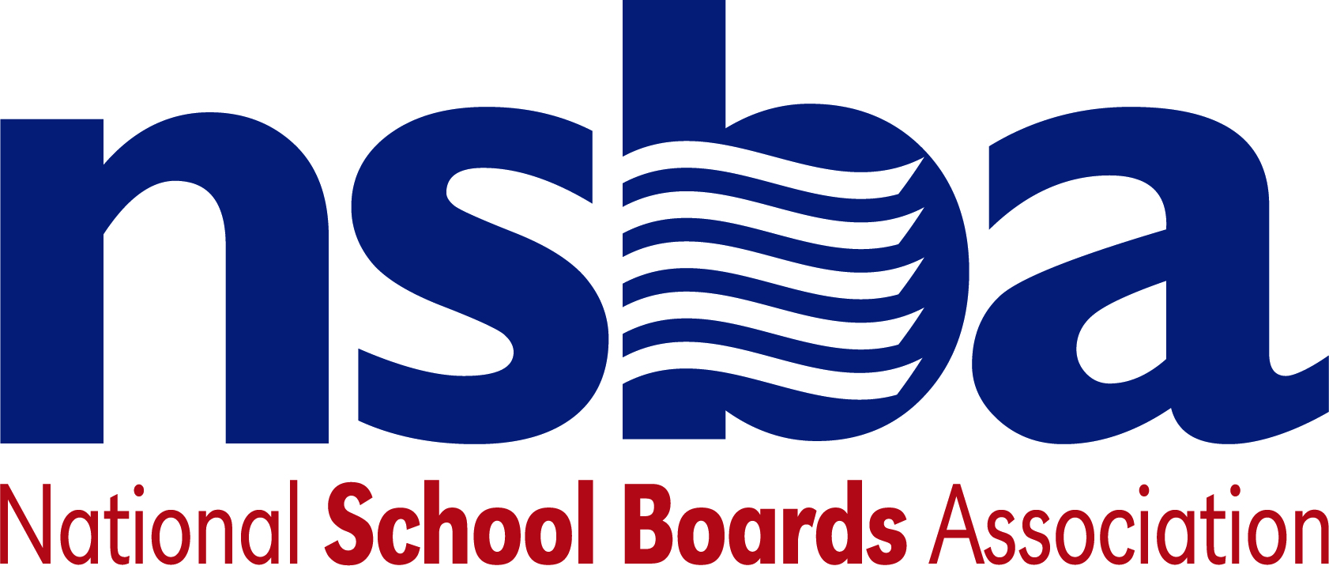

Federal Advocacy & Public Policy Team
April 23, 2021
NSBA Weekly Update

Congressional Update

Senate Republicans Release Infrastructure Counteroffer
Late last month, President Biden unveiled a long anticipated legislative framework to invest roughly $2.3 trillion in infrastructure projects. This proposal, dubbed the American Jobs Plan, would include over $100 billion in funding specifically dedicated to modernizing and building new K-12 school facilities. It would also heavily invest in the nation’s digital infrastructure, proposing $100 billion to expand broadband access and affordability. Congressional Republicans, however, have largely been opposed to President Biden’s vision investments in the nation’s infrastructure, primarily arguing that the proposal is too costly and would raise taxes.

On Thursday, April 22, a group of Senate Republicans led by Sen. Capito (R-WV) released a $568 billion high-level framework outlining the caucus’ counter proposal to President Biden’s American Jobs Plan. Unlike the Biden administration’s plan, Senate Republicans do not intend to invest in the nation’s K-12 schools as part of an infrastructure package. Additionally, the counter proposal envisions $35 billion less for the nation’s digital infrastructure. Unlike the American Jobs Plan, which proposes significant tax increases on corporations and the wealthy to pay for President Biden’s proposed infrastructure investments, the Senate Republican proposal merely provides principles for financing methods (also known as “Pay-fors”). As Congressional discussions continue regarding infrastructure investments, NSBA will continue to advocate for a robust investment in K-12 schools and facilities throughout the country.

Senate Education Committee Advances Nominees
The Senate Health, Education, Labor, and Pensions (HELP) Committee held an executive session on Wednesday, April 21, to finalize its consideration of a pair of U.S. Department of Education (USED) nominees. The committee voted 14-8 to approve and advance Cindy Marten’s nomination to be Deputy Secretary of Education—the number two slot at the Department. The HELP Committee also advanced James Kvaal’s nomination by a vote of 19-3 to serve as the next Under Secretary of Education, a posting that will oversee postsecondary policy for the Department. Both nominations will now advance to the full Senate chamber for further consideration and a final vote. In addition, President Biden announced his intent to nominate former Congresswoman Gwen Graham (D-FL) to lead USED’s Office of Congressional and Legislative Affairs. Graham’s nomination is still forthcoming and must be considered and approved by the Senate HELP Committee and the full chamber sometime in the future.

Administration Update

USED Unveils New MOE Guidance
On Monday, April 19, the U.S. Department of Education (USED) released new guidance pertaining to maintenance of effort (MOE) provisions contained in several pandemic relief funding measures, including the recently passed American Rescue Plan (P.L. 117-7). These MOE provisions require states to maintain levels of fiscal support for K-12 and higher education comparable to funding levels from previous years. In this way, Congress can ensure federal pandemic relief dollars are being used to provide additional support for schools, institutions, and students, rather than being used as a temporary replacement for state funding. This guidance provides an in-depth look at how states should implement the various MOE requirements contained in all three major pandemic relief packages to date. The guidance document also lays out the process for which states can apply to USED to waive this requirement, including a related request form that states must use to formally request a waiver of these provisions from the Department.

USDA Extends Meal Flexibilities Through 2022
On Tuesday, April 20, the U.S. Department of Agriculture (USDA) announced the extension of current flexibilities for school meal programs through June 30, 2022. These flexibilities, aimed at providing maximum access to meals for students struggling with food insecurity during the pandemic, were previously set to expire September 30, 2021. With this action, schools across the country will continue to be able to serve free meals to all students regardless of their family income status.

USED Releases State Plan Template and Additional ARP Guidance
On Thursday, April 22, the U.S. Department of Education (USED) released an interim final rule detailing new requirements states and school districts must meet in order to receive the remainder of their American Rescue Plan funding. Late last month, USED released over two-thirds of the total $122 billion authorized by the ARP for the Elementary and Secondary School Emergency Relief (ESSER) fund to states and school districts. At the time, USED indicated that the remainder of this funding would be contingent on the submission of plans to safely reopen K-12 schools for in-person instruction. The Department is currently soliciting feedback on this rule and comments can be submitted here.

Bills
- H.R.2733 — 117th Congress (2021-2022) To amend the Elementary and Secondary Education Act of 1965 to provide grants to States to establish a comprehensive school career counseling framework. Sponsor: Rep. Langevin, James R. [D-RI-2]
- H.R.2722 — 117th Congress (2021-2022) To amend the Elementary and Secondary Education Act of 1965 to require local educational agencies to implement a policy on allergy bullying in schools, and for other purposes. Sponsor: Rep. Cartwright, Matt [D-PA-8]
- H.R.2717 — 117th Congress (2021-2022) To establish a grant program to encourage schools to conduct independent facility security risk assessments and make hard security improvements, and for other purposes. Sponsor: Rep. Williams, Roger [R-TX-25]
- H.R.2693 — 117th Congress (2021-2022) To amend the Richard B. Russell National School Lunch Act to require that only a school food authority that had a negative balance in the nonprofit school food service account on June 30th of the year preceding the previous school year shall be required to establish a price for paid lunches. Sponsor: Rep. Hartzler, Vicky [R-MO-4]

NSBA Update

Reminder of Upcoming Advocacy Institute June 8-10, 2021: The NSBA federal advocacy and public policy team is excited to be focused on organizing this year’s Advocacy Institute which will take place June 8-10, 2021. We urge you and your members to participate in this major online event championing public schools. nsba.org/AI2021

CSALS Meeting on Monday, April 26, 2021 at 4:00 pm eastern: The agenda for this Monday’s CSALS meeting will go out the day of the meeting. The logistics can be found below:

Topic: CSALS Meeting
Time: Apr 26, 2021 04:00 PM Eastern Time (US and Canada)

Join Zoom Meeting
https://zoom.us/j/91793820443

Meeting ID: 917 9382 0443
One tap mobile
+13017158592,,91793820443# US (Washington DC)
+16468769923,,91793820443# US (New York)

Dial by your location
+1 301 715 8592 US (Washington DC)
+1 646 876 9923 US (New York)
+1 312 626 6799 US (Chicago)
+1 346 248 7799 US (Houston)
+1 408 638 0968 US (San Jose)
+1 669 900 6833 US (San Jose)
+1 253 215 8782 US (Tacoma)
Meeting ID: 917 9382 0443
Find your local number: https://zoom.us/u/ad7WPA3nFi

